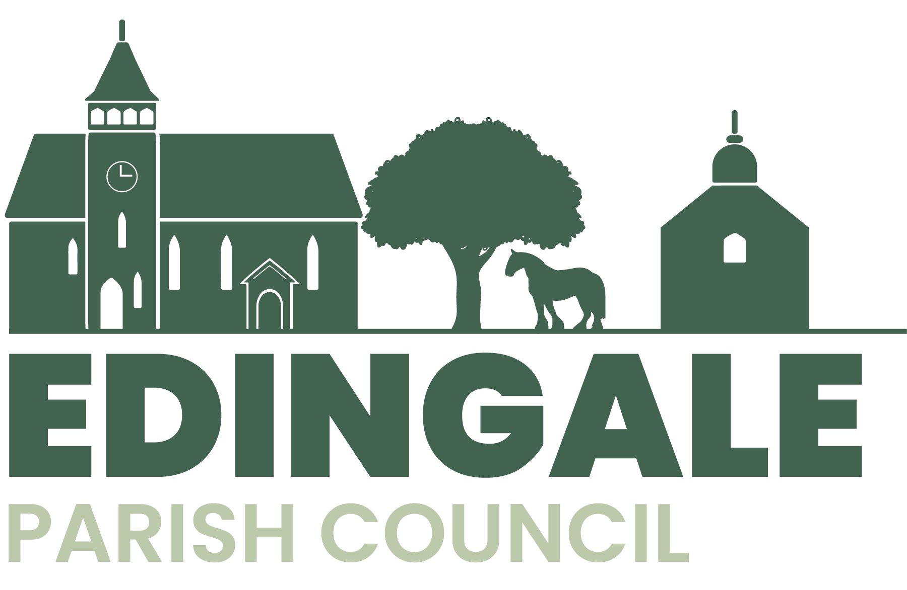
Notice of the Annual Parish Meeting
Edingale Village Hall on Tuesday 7th May at 7.30
followed by the Annual Meeting of Edingale Parish Council
A G E N D A
- To approve the Minutes of the Annual Parish Meeting held on 15th May 2023.

- To receive reports from village organisations.

- To receive questions, comments and suggestions from residents.
Signed
J.Startin
Chair of Edingale Parish Council

