**Edingale Village gearing up for bumper Village Show**

Excitement is building in and around Edingale as villagers get ready for the Edingale Show on Saturday 13h September 2025. Whether they are seasoned bakers, first-time flower growers, new to needlework or familiar with photography, there are lots of show classes to enter and fun to be had.

There is live entertainment from local band The Wake Mason Duo and Andy Smith and Phil Warrington. Visitors can browse the many craft stalls and there will be activities for all the family. The show usually has a good turnout of vintage and classic cars and tractors. Food options will include a BBQ and local craft ale sold from the bar.

Our special guests are

* Everyone Health - mobile health van; come and get your free NHS check
* Midlands Air Ambulance with a helicopter body replica
* Microlight School Fisherwick with a microlight plane; win a 30-minute experience flight voucher in our raffle.
* Staffordshire County Council Waste minimisation roadshow helping us to recycle and reduce waste.
* Flood Risk Management from Staffordshire County Council providing information, support and advice

The heart of the show is, of course, the competitive element with 39 classes for everything from the longest runner bean to crafts and baking to children’s posters. Full details are on Edingale Village Hall’s Facebook page. Anyone can enter and entries must be delivered to the Village Hall on Friday 12th September between 4.00pm and 7.00pm. Prize winners will be announced at 2.00pm on show day with certificates and cups presented by Rev Nicky Busby.

Entry to the show on Saturday is £3.50 for adults with under 16s free.

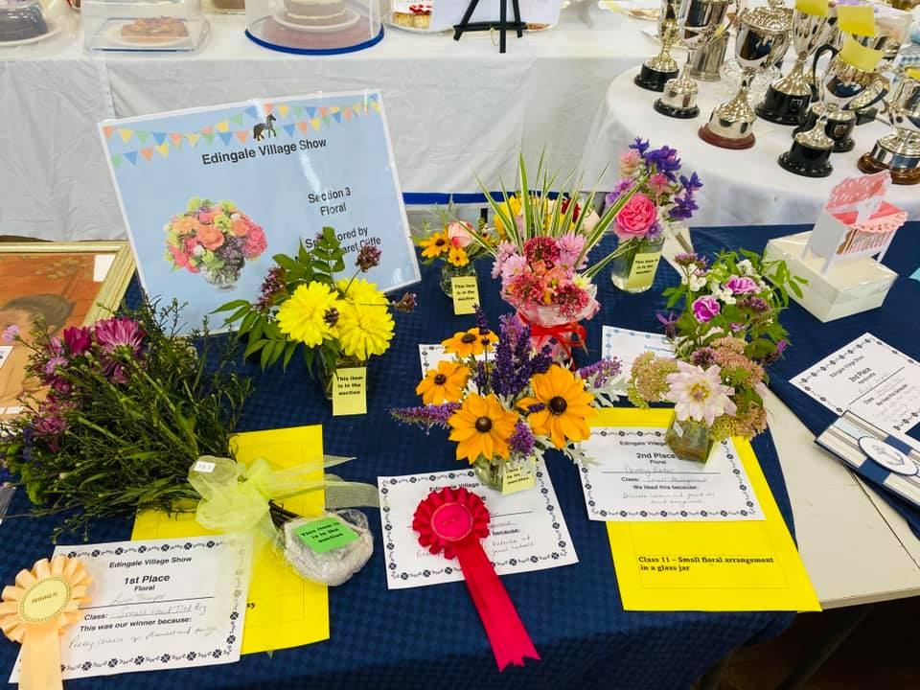

Last year’s Show entries

Visiting friends

Entertainment

Plants for sale

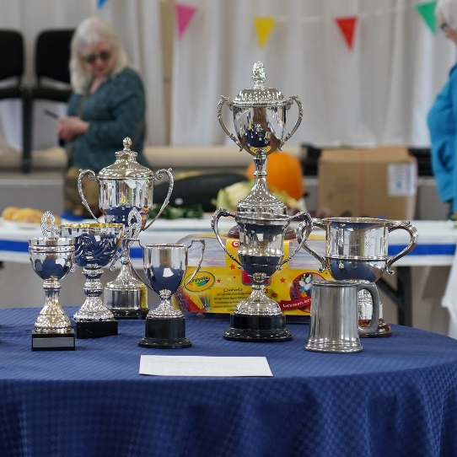Trophies to be won